IT2120 - Probability and Statistics

Lab Sheet 07

IT24104028

Wikramasinge J L L P

**Exercise**

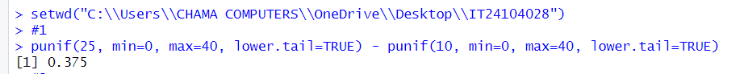**01)**

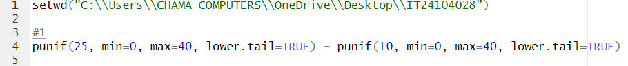

**02)**





**03)**

1. 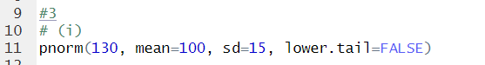

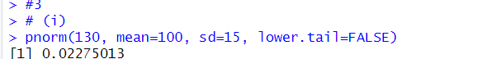

1. 

